

Relationship & Behaviour Policy

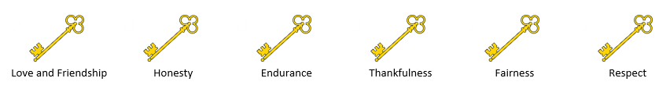

At Rawdon St Peter’s we inspire, nurture and immerse ourselves in the world around us, exploring and embracing new opportunities. We promote love and friendship, honesty, endurance, fairness, thankfulness and respect, preparing us for new situations and challenges that life can bring. As God taught us, we love ourselves, each other and welcome everyone, exploring cultures and beliefs together. We learn together. We love together. We grow together.

I came to give life – life in all its fullness (John 10:10)

Statement of Intent

Rawdon St Peter’s Church of England Primary School believes that, in order to facilitate teaching and learning, acceptable behaviour must be demonstrated in all aspects of school life.

We are fully committed to giving our children the unconditional positive regard that they need to feel happy, safe and secure, whilst helping them to understand their own behaviour choices and how their choices impact on others.

In doing this, we have developed a culture of respect for all, equality of opportunity and endless tenacity to remove barriers for children now and help them to be successful in adult life. We aim to create an open culture around the discussion of mental health and wellbeing to empower our children to be able to understand their choices and regulate their emotions.

How we do it, is not based on a punitive set of rewards and consequences but is encapsulated in the relationship between adult and child and the relentless investment into the quality of this based on identifying and promoting self-esteem, self-worth and high expectations. We reward the positives and help children understand their behaviours in order to make good and safe choices as they progress through the primary phase and on to secondary school

All staff and children contribute to this culture. This is what makes Rawdon St. Peter’s Primary School unique. Relationships are the cornerstone of the culture of our school.

Legal Framework
This policy has due regard to all relevant legislation and statutory and non-statutory guidance including, but not limited to, the following:
- Education Act 1996
- Education Act 2002
- Education and Inspections Act 2006
- Health Act 2006
- The School Information (England) Regulations 2008
- Equality Act 2010
- Voyeurism (Offences) Act 2019
- DfE (2013) ‘Use of reasonable force’
- DfE (2015) ‘Special educational needs and disability code of practice: 0 to 25 years’
- DfE (2018) ‘Mental health and behaviour in schools’
- DfE (2024) ‘Behaviour in schools: Advice for headteachers and school staff’
- DfE (2025) ‘Keeping children safe in education 2025’
- DfE (2022) ‘Searching, Screening and Confiscation: Advice for schools’
- DfE (2023) ‘Suspension and Permanent Exclusion from maintained schools, academies and pupil referral units in England, including pupil movement’
- DfE (2024) ‘Mobile phones in schools’
- DfE (2024) ‘Creating a school behaviour culture: audit and action planning tools’

This policy operates in conjunction with the following school policies:
- Child Protection and Safeguarding Policy
- Anti-Bullying Policy
- Suspension and Exclusion Policy (Leeds City Council Model Policy)
- RSE Policy
- Staff Code of Conduct
- Physical Intervention Policy

Roles and Responsibilities
The governing board will have overall responsibility for:
- Making a statement of behaviour principles, and providing guidance for the headteacher on promoting good behaviour where appropriate.
- Ensuring that this policy, as written, does not discriminate on any grounds, including, but not limited to, age, disability, gender reassignment, gender identity, marriage and civil partnership, race, religion or belief, sex and sexual orientation.
- Promoting a whole-school culture where calm, dignity and structure encompass every space and activity.
- Handling complaints regarding this policy, as outlined in the school’s Complaints Procedures Policy.
- Ensuring this policy is published on the school website.

The headteacher will be responsible for:
- The implementation and monitoring of this policy
- The behaviour procedures at the school.
- Overseeing the whole-school approach to mental health, training for staff and engagement with parents.
- Reporting to the governing board on the impact of this policy.
- Providing additional support where and if needed.

The SENCO will be responsible for:
- Undertaking day-to-day responsibilities for the successful operation of the behaviour and SEMH policies to support pupils with SEND, in line with the school’s Special Educational Needs and Disabilities (SEND) Policy.

Teaching staff will be responsible for:
- Planning and reviewing support for pupils with behavioural difficulties in collaboration with parents, the SENCO and, where appropriate, the pupils themselves.
- Planning and delivery of lessons using adaptive teaching strategies to ensure that every pupil achieves their full potential.
- Teaching and modelling expected behaviour and positive relationships, demonstrating good habits.
- Being responsible and accountable for the development of the pupils in their class.
- Not tolerating disruption and taking proportionate action to restore acceptable standards of behaviour.
- Developing effective communications with parents, ensuring that they feel included in their child’s educational experiences.

All members of staff, including teaching and support staff, and volunteers will be responsible for:
- Adhering to this policy and applying it consistently and fairly.
- Supporting pupils in adhering to this policy.
- Promoting a supportive and high-quality learning environment.
- Modelling high levels of behaviour.
- Being aware of the signs of behavioural difficulties.
- Setting high expectations for every pupil.
- Being aware of the needs, outcomes sought, and support provided to any pupils with specific behavioural needs.
- Developing supportive, respectful, and trustworthy relationships with each other.

Pupils will be responsible for:
- Their own behaviour both inside school and out in the wider community.
- Reporting any unacceptable behaviour of others, to an adult

Parents will be responsible for:
- Supporting their child in adhering to the school rules and reinforcing this at home.
- Informing the school of any changes in circumstances which may affect their child’s behaviour.
The Nine Aspects of Our Relationship Policy

At Rawdon St. Peter’s, our approach to relationships and behaviour is based around our 6 key Christian values, promoting positive mental health, emotional wellbeing and developing pupils’ spiritual and moral code within the Christian community and faith.

We recognise the need for strong relationships and the importance of remaining consistent in our approach through our nine key aspects:

- School Rules
- Visual Timetables
- Soft Start - Meet and Greet
- Rewards
  - Dojos
  - Whole Class Rewards
  - Lunchtime Tokens
  - Be the Best you can be Award
  - Learning Reflections
- Kindness Charter
- Bucket Filling
- Restorative Conversations
- RIP and PIP
- Zone of Regulation

- School Rules
We have three very simple and very clear school rules:
1. Ready - We always follow instructions from a known adult in school and are ready to do as asked.
2. Safe - We always keep ourselves safe and never hurt others.
3. Proud - We always make choices and behave in a way that makes us proud of who we are.

Pupils are expected to know these school rules by heart and follow them at all times. They are used at all times throughout school including in the playground.

Expectations are discussed, agreed and set in each classroom. These are centred around the ‘Ready, Safe, Proud’ rules. If pupils are part of the discussions of what we should see in school, they are more likely to adhere to them and understand their importance and impact of their behaviours. The agreed rules are displayed in all classes so that it is clear to all what the rules and expectations are.
Expectations | What does this look like? | Why is it important?
READY | - We are in the right place at the right time.  - We have the right equipment for our learning (eg. correct uniform / PE kit/ stationery pack).  - We will use our eyes and ears to attend to the speaker.  - We engage with all learning tasks set for us. | To make the most of the opportunities we have at school.
SAFE | - We use and store equipment appropriately (eg. stationery, PE equipment).  - Our behaviour is appropriate to the environment we are in. (eg. walk on the left in the corridor, active areas for football/basketball, quiet areas for chatting with friends).  - We sit on the carpet and our chairs safely. | To keep ourselves and others in our school safe.
Proud | - We make everyone feel welcome (eg. Use good manners, say good morning/afternoon, hold doors open).  - We use quiet voices inside and speak kindly to each other.  - We show respect for our school and classroom environment by keeping it tidy. | To help us to grow into good citizens who contribute well to the community.

Along with our key values, these aspects underpin our whole school and are the basis for how we form meaningful relationships – adult to adult, child to adult and child to child – and promote positive behaviours and emotional wellbeing.
- Visual Timetables
Each classroom displays a visual timetable which is updated and discussed briefly at the end of each day in preparation for the next day. This then means that children come to school each day knowing what is happening and when.

Visual timetables should be displayed in the classroom where they can be seen by all the children in class, using an appropriate picture and font size. The same pictures are used across school, from classroom to classroom to support transition.

- Soft Start - Meet and Greet

Each morning, we operate a ‘Soft Start’ for entry into school. Teachers remain in their classrooms to greet the pupils upon arrival in a positive manner and with a smile. We do this to make our pupils feel welcome and formally mark the start of the day. There will be a gentle activity available each morning that the children will access; this helps to set the expectation for the day, with the children routinely settling to their work and engaging in their learning.

Learning Support Assistants are positioned at doors to follow the same approach and ensure the children quickly make their way to classrooms, ready to start their morning learning, supporting a positive mindset.

At this point, adults can check emotional wellbeing and take swift action to support children who may need additional support to settle into the day.

- Rewards

Dojos
Our children need to know when they are doing well and have made the right choices. In reinforcing their actions, children will be motivated to continue to work hard and making positive choices. The aim is for the pupils to receive extrinsic rewards for them to learn for their positive behaviours to become intrinsic.

In doing this, children can earn Dojos. They can earn them for any aspect of school life that their class teacher feels deserves. Dojos can be given in recognition of our school values, making great contributions in lessons, being the best that you can be and generally having a great day. Adults love giving praise and our Dojos emphasise the recognition of making positive choices. It is the job of the adult to create a climate where children can gain Dojos and feel positive.

The pupils can exchange their dojos for experiences at our Dojo Shop. These reward experiences are decided by school council and reviewed on an annual basis. Pupils can choose to either spend their Dojo’s as soon as they have enough for an experience or save them for an even bigger reward. To claim a chosen experience, children complete a Dojo Shop slip, ticking off the experience they wish to redeem. This can be done at the end of a week and pupils will then receive their experience at the end of each half term. Pupils have full ownership over how and when they decide to spend their Dojos.

By downloading the free version of the Dojo App, parents are able to see how many Dojo’s their child has, when they were given and by who. This will allow those at home to have supportive conversations to celebrate their child’s hard work and achievements.

Whole Class Rewards
Each half term, adults in classes work alongside pupils to set a class reward. This whole class half termly reward allows both pupils and staff to work together to create a positive team work ethic in their class. As well as agreeing the whole class reward, the class work together to agree how they will achieve it. For example, by gaining a given number of marbles in a jar.

The agreed class reward is displayed in each classroom to act as a visual reminder which can also be referred to as needed.

The rewards are earned by the class as a team and not guaranteed.

Learning Reflection
Our pupils are supported to develop their understanding of what helps them learn well. Classes hold a short learning reflection before break, before lunch time and at the end of the day. During this time, they consider how well the lesson has gone and why. This approach helps our children develop their self-awareness, enabling them to learn from experiences and develop their interpersonal abilities.

Pupils are award Dojos to reward them for their honest and thoughtful reflections.

Lunchtime Tokens
The same expectations are followed at lunchtimes. During this time, adults can give children a coloured token linked to their ‘Team’ (England, Northern Ireland, Scotland, Wales) in recognition of their excellent behaviour choices, applying our school values and having positive interactions with others. At the end of each half term, the team with the most tokens receive a non-uniform day in recognition of their team earning the most tokens, due to their positive behaviour choices at lunchtimes.

Be the Best you can Be Award
At Rawdon St. Peter’s once a week on Friday adults choose two pupils from their class, who are recognised for exemplary behaviour, attitudes and conduct in school. These are pupil who consistently makes the right choices and give everything they do their best effort. They promote our school values, have a fantastic approach to their mindset and have gone above and beyond with their behaviour and learning. Children who receive these awards are celebrated in our Friday Collective Worship.

In recognition of this award, children are invited to have drinks and a biscuit with the Headteacher, Deputy Headteacher or appropriate member of Senior Leadership each Friday. This is an extra opportunity to praise pupils who have achieved this award and let them know how proud we are of them.
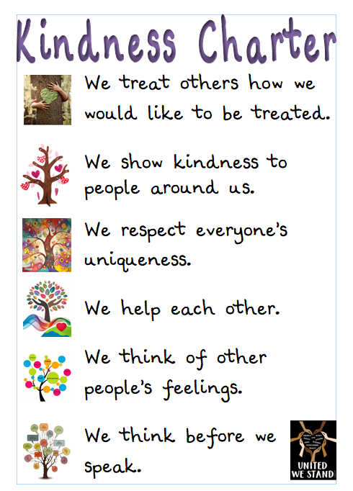
- The RSP Kindness Charter
The Rawdon St. Peter’s Kindness Charter has been written by the children and adults in our school. It has been written to promote ongoing kindness across school and supports pupils and adults understanding of what it means and feels like to be kind to others.

Our school community know that in a world when you can be anything, be kind.

- Bucket Filling
Bucket Filling is based on the book ‘Have you filled a bucket today?’ Pupils and staff look for opportunities to recognise positive behaviours and acts of kindness. These are collected in personal buckets and comments received are collected into books – so pupils have a record of positive comments made about them. This encourages pupils to value the feelings generated by doing something positive for others and the intrinsic reward they receive.

Comments can be added to buckets at appropriate times throughout the week and are then shared during Collective Worship Reflection which takes place each Thursday.

To allow buckets to be filled across school, communal buckets can be found in key spaces, where pupils and adults can pay those in our wider school community a compliment.

6. RIP and PIP

Praise in Public
All staff give regular praise to pupils to reinforce their positive behaviour choices. Regular praise helps our pupils understand that they are doing well and making great choices. Praise should always be as specific, targeted, public and sincere. This is what gives it power. This is done through our ongoing use of Dojos, use of stickers and by offering verbal praise.

Reprimand in Private
Reprimand should be calm, private conversations or re-directions through coaching conversations, that only the child who it is intended for can hear. Adults always speak to children calmly, with the greatest respect and with positivity.

Adults follow a restorative approach to conversations alongside a tone of voice that is reflective and appropriate of the situation that is being dealt with. RIP may take place in different forms appropriate to the conversation and the incident. For example:

- A quiet word at the pupil's desk: Approaching the child discreetly during independent work to address the behaviour.
- A brief conversation in a quiet corner of the classroom: Moving the child to a less public space within the classroom for a quick discussion.
- A short meeting outside the classroom: Stepping into a corridor or quiet area for a more focused conversation.
- Using a pre-arranged signal: A subtle cue to the child that their behaviour needs to change, followed by a private conversation later.
- Addressing the behaviour after the lesson: Discussing the incident with the child individually once the immediate situation has passed.
Children will be made aware that a coaching conversation will be recorded on CPOMS. This allows leaders and teachers to identify patterns of behaviours, see where improvements are not being made and where more support may be needed. This may then lead to a conversation with parents and a more bespoke response.
Adults at Rawdon St. Peter’s never shout at children, express negativity, sarcasm or use derogatory tones towards our pupils.

7. Restorative Conversations
At Rawdon St Peter’s, we have created an environment where children are given time and space to put things right. This is done through Restorative Conversations, helping children to connect in order to correct.

A restorative conversation is a dialogue focused on repairing relationships damaged by conflict or harm, promoting reflection and repairing harm in a positive and constructive manner. It's not about punishment, but rather about understanding the impact of actions, taking responsibility, and finding ways to make things right.

These conversations are facilitated by adults who support the understanding of the children they are working with. The aim is for the restorative conversation to help everyone involved to understand what has happened, understand how everyone involved is feeling, then seek to repair the relationship and agree a way forward ensuring what ever the issue is does not reoccur.

Children will be made aware that restorative conversations will be recorded on CPOMS. This allows leaders and teachers to identify patterns of behaviours, see where improvements are not being made and where more support may be needed. This may then lead to a conversation with parents and a more bespoke response.
8.Zones of Regulation

The Zones of Regulation is a framework that develops awareness of feelings, energy and alertness levels while exploring a variety of tools and strategies for regulation, social skills, self-care, and overall wellness. It provides us with an easy way to think and talk about how we feel on the inside and sort these feelings into four coloured Zones, all of which are expected in life.

The emotional vocabulary and colours, is a language that is commonly used around school by both pupils and adults and it is recognised that the colour a person may be feeling can change throughout the day.
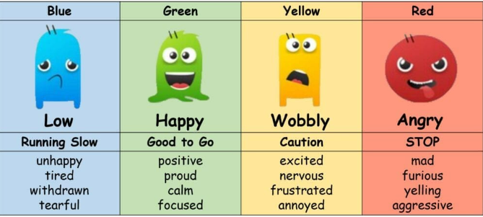
Once we understand our feelings and zones, we can learn to use tools/strategies to manage our different Zones in order to meet goals like doing schoolwork or other tasks, managing big feelings, and healthy relationships with others. In using the Zones of Regulation, we aim to teach our pupils to identify emotions in themselves and others and provide them with a bank of strategies to support their emotional wellbeing. This approach is used at appropriate times such as reflection times or during restorative conversations.

What are the different Zones?
Blue Zone: low level of alertness; not ready to learn; feels sad, sick, tired, bored, moving slowly.
Green Zone: calm state of alertness; optimal level to learn; feels happy, calm, feeling okay, focused.
Yellow Zone: heightened state of alertness; elevated emotions; has some control; feels frustrated, worried, silly/wiggly, excited, loss of some control.
Red Zone: heightened state of alertness and intense emotions; not an optimal level for learning; out of control; feels mad/angry, terrified, yelling/hitting, elated, out of control.

Poor Behaviour

We deal robustly with behaviour that falls short of our high expectations. If a pupil chooses not to follow the rules there is a structured response to help get them back on track.
- One Rule Broken: Adult explains to the child privately which rule they have broken. The expectation is re-iterated to the child, calmly, clearly and supportively. The adult explains the behaviour they are looking for and state an expression of encouragement to see this behaviour. When the child is seen exhibiting the desired behaviour, they are rewarded with dojos.

Example: ‘Simon, can you help me understand why you are shouting out when I am talking? When I am talking, its really important that you listen and don’t shout out. Why don’t we shout out? My expectation is that when I talk, you listen.’

- Two Rules Broken: As above, but this time the adult needs to set a personal target. On this second occasion, the tone and approach used should be firm but fair. A personal target is given verbally. The adult then has to concentrate on making sure they catch the pupil doing the right thing and allowing them to gain Dojos and get back on track. Praise is powerful. Targets set will be specific and time limited to the end of a lesson. If the target has not been met before the end of the lesson, the class teacher will remind the pupil of the expectation again privately, as the lesson finishes.
Example: ‘Simon, I have asked you once not to talk when I am talking to the class. Do you understand what I expect of you? My expectation is that when I am talking you listen.’
- Three Rules Broken: At this stage your reminders and clarity of expectations have not had the desired effect. The tone used by the adult should be firm and clear. This pupil clearly needs greater intervention to meet the behaviour expectations. The adult will use the class walkie-talkie to contact the Senior Leader who is on duty to meet with the child outside the classroom. With privacy, they will have a restorative coaching conversation with them. This will explore what has happened, attempt to get to the heart of the problem, re-iterate expectations and also make clear that one further episode of behaviour will result in a conversation with parents and having to work outside the classroom for the rest of the lesson or even the rest of the day. This coaching conversation will be recorded on CPOMS.

- Four Rules Broken: This is the final sanction and the pupil will be taken by an adult to the Head Teacher where they will have a coaching conversation. If this is not possible, the headteacher will go to them. The pupil will then work in an appropriate space in school but not in the classroom. The aim is always to reintegrate the pupil back into the classroom however this will be done at the leader’s discretion and only when the leader working with the children is confident a pupil is regulated and ready to learn. Reintegration may include:

- Initial Check-in: A brief, calm conversation with a designated adult (teacher, teaching assistant, learning mentor) before re-entering the classroom to discuss readiness and expectations.
- Visual Supports: Using visual schedules or social stories to remind the child of classroom routines and expectations.
- Gradual Re-entry: Depending on the child and the situation, a phased return might be appropriate (e.g., joining for a specific activity first).
- Peer Support: Strategically pairing the child with a supportive peer who can model positive behaviour.
- Differentiated Tasks: Providing initial tasks that are achievable and build confidence upon their return.
- Positive Reinforcement: Explicitly acknowledging and praising positive behaviour and engagement upon reintegration.
- Opportunities for Repair: If the behaviour impacted others, facilitating a restorative conversation or activity.
- Follow-up: A brief check-in later in the day to review how the reintegration went.

The Head Teacher will confirm to the child that they are going to contact their parent/carer to inform them of the incident and will record the incident on CPOMS.

Repeating Poor Behaviour
There may be occasions where despite our best efforts, the behaviour a pupil exhibits do not improve and becomes disruptive to the learning and educational experience of others. Should this happen, the headteacher or member of staff with delegated responsibility will arrange a meeting with parents to discuss and agree a more bespoke approach, the use of movement breaks, use of a quiet space to reflect, a check in with another adult for an additional coaching conversation.

The agreed way forward should always be logical and proportionate to the behaviours being exhibited.

Behaviour at Playtime & Lunchtime
It is important that all pupils feel safe on our playground. Where behaviour at lunchtime falls short of the high expectations, or there is an instance of inappropriate or aggressive behaviour, the headteacher or person with delegated responsibility, will discuss this with the pupil and contact parents to agree a way forward.

Supporting Children with Additional Needs
The school acknowledges that behaviour can sometimes be the result of educational needs, mental health issues, or other needs or vulnerabilities. We will address these needs via a more individual response.

Strategies used may include:
- Sensory Circuits
- Personalised Timetables
- Emotional Check ins
- Behaviour Maps
- Prompt Cards/non-verbal cues
- Movement Breaks
- Sensory Breaks
- Adaptive Teaching Strategies

In creating an individualised response, we will work in partnership with parents as appropriate.

Physical Intervention

In line with the school’s Physical Intervention Policy, and advice given in Use of Reasonable Force (2023), trained members of staff will have the legal right to use reasonable force to prevent pupils from committing an offence, injuring themselves or others, or damaging school property, and to maintain good order and discipline in the classroom. At Rawdon St Peter’s our approach to physical intervention is called Team Teach.

Team Teach techniques prioritise the safety of both staff and pupils and aim to avoid injury to the service user. However, it is important to acknowledge that despite the use of appropriate and trained techniques, it is possible that bruising or scratching may occur accidentally during a physical intervention. Such occurrences are not necessarily indicative of a failure of professional technique but can be a regrettable and infrequent 'side-effect' of ensuring the immediate safety of the individual and others in situations where all other de-escalation strategies have been exhausted.

Physical restraint will only be used as a last resort and as a method of restraint. Staff members will use their professional judgement of the incident to decide whether physical intervention is necessary. In doing so they will notify the Senior Leader on Call and headteacher who will attend. The situations in which physical restraint may be appropriate are detailed in the Physical Intervention Policy. Wherever possible, staff will ensure that a second member of staff is present to support the physical intervention used.

When using reasonable force in response to risks presented by incidents involving pupils with SEND or medical conditions, staff will recognise and consider the vulnerability of these groups.

Following an incident where physical intervention has been used, the members of staff involved will have a debrief meeting with the headteacher or member of staff with delegated responsibility. Contact will also be made with parents.

Behaviour outside school

We expect high standards of behaviour from our children in school. We encourage them to remember that they represent our school at all times and so their behaviour in the local community matters. It is important that positive behaviour is promoted outside of the school and any inappropriate behaviour dealt with. Therefore, the policy will also apply when our children are:
• Taking part in any school-organised or school-related activity;
• Travelling to or from school;
• Wearing school uniform;
• Serious incidents outside of school involving other school children*;

*Where we are unable to fully investigate serious incidents outside of school, the impact of these on school behaviour will be considered.

Supporting Behaviour Outside of School

Parents are welcomed and encouraged to use RSP strategies to manage behaviour of children at home. If a child’s behaviour at home becomes concerning and further support is needed, parents are encouraged to speak with a member of staff who can signpost to useful advice or support.

Serious Behaviour

Any violent or threatening behaviour will not be tolerated by the school and may result in a suspension in the first instance. It is at the discretion of the headteacher to determine what behaviour necessitates a suspension, in line with the Suspension and Exclusion Policy.

Any behaviour which is so extreme it would be inappropriate for it to be dealt with via our system of rules should be referred to the headteacher. This will result in a phone call home to parents, a meeting with parents and potentially internal exclusion from class for a period of time.

Where serious behaviour is repeated, it may be appropriate to set a more individual approach support. This will be discussed with parents.


Appendix 1

A Protocol for Unannounced Police Visits
- The police may visit school to speak to children about a child protection investigation or if they are investigating a crime or allegation. Should a visit be in relation to child protection, the Designated Safeguarding Lead is usually notified in advance via Children’s Social Care.

- If the police arrive at school, without notice, to see either a child, group of children or an adult, the Designated Safeguarding Lead must be notified immediately. This includes interrupting a meeting or phone call.

- If the Designated Safeguarding Lead is not in school, a Deputy Safeguarding Lead should meet with the officer, listen and gather information to confirm why they have come to school.

- The Deputy Safeguarding Lead should then contact the Designated Safeguarding Lead via telephone or video call to share this information and confirm next steps.

- If the Designated Safeguarding Lead is not available, the Deputy Safeguarding Lead should contact another experienced Headteacher within the Aireborough Learning Partnership Trust for advice.

- Staff at Rawdon St Peter’s will not act in Loco Parentis in relation to legal or police matters without prior written consent from parents.


Whilst safeguarding our pupils, it is our right to ask questions and ensure that decisions made are supporting a child’s welfare and are not made without parental consultation or consent, unless doing this would place the pupil at risk. While schools act in loco parentis through a duty of care, they are not obligated to divulge confidential information to the police. The head teacher must be satisfied that it is essential before allowing police interviews with pupils on school premises.

Staff at Rawdon St Peter’s will not act in loco parentis when/if it would be possible for a parent to carry out this role themselves, even if it is at another time and venue.

Key Definitions

Appropriate Adult

The role of the appropriate adult is to safeguard the interests, rights, entitlements and welfare of children and vulnerable people. In school this may mean sitting with a child whilst they are spoken to by a police officer or social worker.

Loco Parentis (in place of a parent)

In loco parentis is the concept that someone with the care of a child stands in for their parent in his or her absence. RSP will act in loco parentis whilst a child is in their care in terms of their duty of care however, by acting in loco parentis, RSP does not assume legal parental responsibility.
Appendix 2 – Relationship Policy
Below are least intrusive intervention strategies that can be used to support positive behaviour when teaching (Lemov.D, 2015). They are key tools for QFT. These are not included in the behaviour rules which lead to intervention from SLT but are there to keep the class on track in a positive way, reinforcing positive behaviours and using praise to reinforce expectations.
- ‘Non-verbal Intervention’ is when you use gestures or your proximity to a pupil to mitigate low-level disruption in a non-invasive way
- The advantage of this technique is that the teaching does not stop while the disruption is being addressed, so the flow of the lesson is not interrupted in any way. It is also a respectful way to refocus pupils because it gives them an opportunity to self-regulate their behaviour without being shamed or embarrassed in front of their peers.
Example of using gestures
- If a pupil is fiddling with their pen or whiteboard during a phonics lesson, you might use a downward hand gesture to signal to the child to put their pen down whilst the rest of the pupils continue to read sounds that you point to on the board.
Example of using proximity
- If you notice a pupil no longer following the text during whole class reading, you might walk closer to where they are sitting whilst continuing to read, to prompt them to follow the text. Here, you’re using your own proximity to the pupil to redirect their attention, without needing to say any words. Other pupils are unlikely to even be aware that you are intervening.
- These are great ways to refocus off-task pupils without stopping teaching. However, such interventions can become invasive if not performed correctly.
Non-example
- A pupil is fiddling with their pen or whiteboard during a phonics lesson, so you use a downward hand gesture to signal to the child to put their pen down and wait, looking at them intently with a frown on your face until they do.
- In the above example, the teacher stops teaching. Therefore, the rest of the class has stopped learning and are now watching the non-verbal communication between the teacher and the off-task pupil. This may embarrass the pupil and causes lost learning time. Always aim to use non-verbal interventions discretely whilst continuing to teach your lesson.
- ‘Positive Group Correction’ is a quick verbal reminder addressed to the whole class.
Why address the whole group rather than individuals?
There are two reasons for this:
- Saying the names of pupils who are not complying with your instructions may cause embarrassment or escalate the behaviour to a confrontation that further disrupts the lesson.
- In addressing the whole class, you may prompt others to check their behaviour who may also be off task - but you hadn’t noticed.
This intervention is best framed in a positive way – by describing the solution rather than the problem. For example, ‘Everybody should have their pens down and eyes to me’. The correction needs to be short and direct so as not to disrupt the flow of the lesson.
If you want to increase accountability of individual pupils, you could non-verbally indicate to a specific pupil whilst still speaking to the whole class.

- Anonymous Individual Correction
- Anonymous Individual Correction’ is similar to the positive group correction in that it is anonymous, and solution focused. However, it additionally informs the class that there are some pupils who are non-compliant. For example, “Eyes on me. I am still waiting for two more pupils”.
- Anonymity reduces the level of disruption caused, as it prevents pupils from being tempted to turn and face the individual being addressed. It addresses the behaviour in a respectful way, helping to maintain an environment of mutual trust and respect.
- This technique also gives pupils more ownership over their behaviour as they identify for themselves that they are one of the pupils who isn’t ready. This has the added benefit of encouraging independence and self-regulation.
- Private Individual Correction
- ‘Private Individual Correction’ is when you address a pupil’s behaviour discreetly whilst the rest of the class are working independently or with peers.
- What happens if the behaviour occurs during whole-class teaching?
- If you notice a pupil is off task whilst you are addressing the whole class, you might give the class a quick task to complete, for example, “Turn to your partner and tell them what you know about topic being covered”. Whilst they are doing this, you can approach the pupil, crouch down next to them, and quietly address the behaviour, for example: “Sunita, it’s important that you understand this method of subtraction. It will help you work independently later. Make sure your eyes are on the board, thank you.”
What makes this effective?
- It describes the solution (“Eyes on the board”).
- It emphasises the purpose to the learner (“It will help you work independently”)
- It is done respectfully and privately, rather than in front of the rest of the class.
- These features help to create a culture of mutual trust and respect which supports the development of effective relationships.
- Lightning-quick Public Correction
- Sometimes it will not be possible to correct a pupil’s behaviour privately.
- In such instances, it is important that the pupil under scrutiny is in the spotlight for as short amount of time as possible. This avoids overly embarrassing the pupil or disrupting the focus and attention of other pupils.
- This type of public correction should be made as quickly as possible: preferably lightning-quick!
Here’s how to do this:
- Name the pupil
- Name the behaviour you want to see (rather than stating what they are doing wrong)
- Bring the class focus back to the positive behaviour that’s happening in the classroom
- Reinforce the pupil’s now on-task behaviour (if it occurs)
Example - Singing a counting song in Early Years:
- “[Pupil name], I need to hear you. Brilliant singing at the back… Much better [pupil name].”
- Private Individual Precise Praise
- One final technique that you may use, not so much to address low-level disruption directly but rather to encourage optimal behaviour and learning, is private individual precise praise.
- ‘Private Individual Precise Praise’ is when you go over to an individual pupil during independent work and whisper some positive praise for the good work or behaviour they have exhibited.
Example
You walk over to a pupil, crouch down near them and whisper, “[Pupil name], the explanation you gave to the class just now was outstanding – well done.”
- This is a strategy that can help you to build effective and trusting relationships with pupils by balancing correction of behaviour or work with praise.

Appendix 3 – Classroom Behaviour Poster




At Rawdon St. Peter’s, we are the best we can be!
This is how we do it:
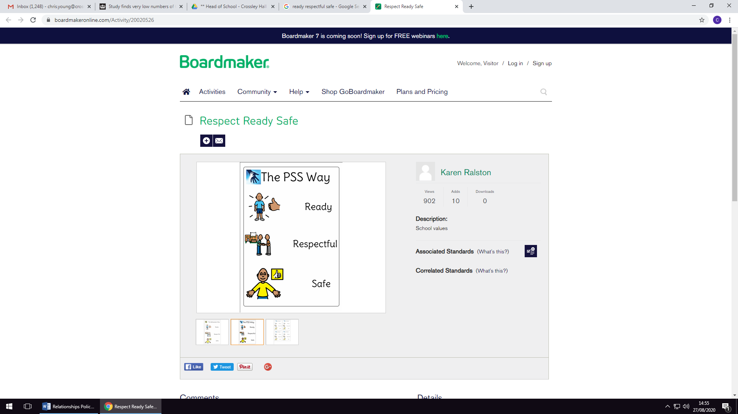
READY!
We always follow instructions from a known adult in school.
SAFE!
We always keep ourselves safe and we never hurt others.
Proud!
We always make choices and behave in a way that makes us proud of who we are

Our Rewards Consequences
    Verbal Praise |   Be the Best you can Be
    Stickers |   Lunchtime Tokens
    Dojos |   Whole Class Rewards
   | Coaching Conversation with an adult in your class to help you understand how you need to change your behaviour.
   | Second Coaching Conversation with an adult in your class who will set you a target to help you get back on track.
   | Coaching Conversation with a member of SLT who will help support and reset to get you back in track.
   | Conversation with the Headteacher. Work outside the classroom. Parent/carer contacted.
   | Serious Behaviour  Immediate conversation with the headteacher. Parents contacted.

Appendix 4 – Unconditional Positive Regard Poster

Unconditional Positive Regard
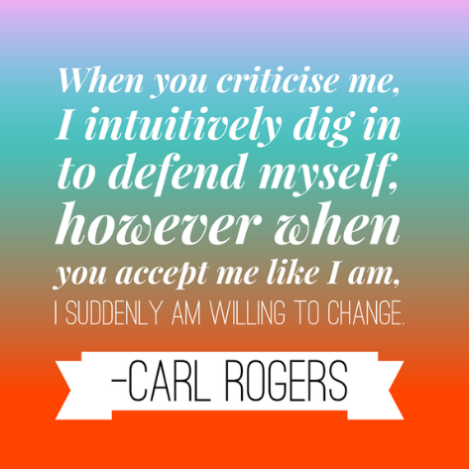
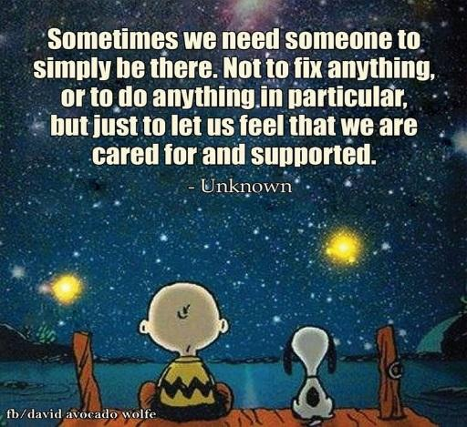
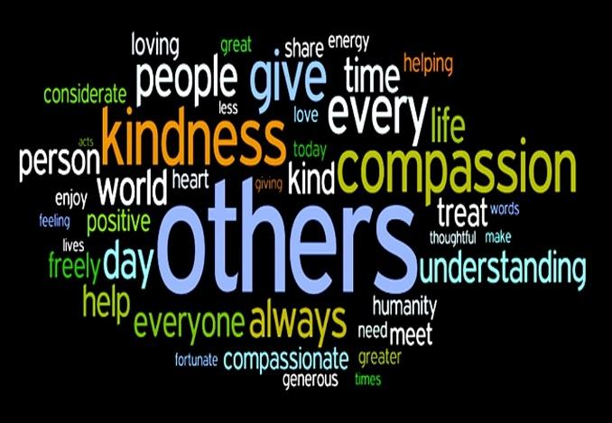
It takes mental effort and commitment.
Why have Unconditional Positive Regard?
Individuals feel accepted, important and cared for.

Builds positive relationships

Individuals are more comfortable to share thoughts and feelings.

Individuals become more positive and it raises expectations.

How do I implement Unconditional Positive Regard?
An appropriate greeting each day which offers a fresh start.
Ongoing Positive and specific praise throughout the day
Positive contact with home
Taking an interest in your pupils
Do not take things personally
Use specific language
Be positive, calm and understanding
Use clear, consistent boundaries with clear expectations
Why do we need Unconditional Positive Regard at RSP?
Supporting the Christian Values of our school.

Increasing level of Mental Health need

Support and challenge in equal measure

Additional Learning Needs

Low Confidence & Self Esteem

What is Unconditional Positive Regard?
An attitude of total acceptance without judgment.
An acceptance and support of each individual exactly how they are
An acceptance of someone regardless of their behaviour, what they do or say


Appendix 5 – Kindness Charter

